Important link

Friday, September 20, 2024

12:25 PM

<https://www.kaggle.com/code/sunilthite/brain-stroke-prediction-using-cnn>  
  
<https://www.spiedigitallibrary.org/journals/journal-of-medical-imaging/volume-10/issue-04/044502/Stroke-GFCN--ischemic-stroke-lesion-prediction-with-a-fully/10.1117/1.JMI.10.4.044502.full#_=_>

IMPORTANT DATASET ISLES2024  
  
<https://www.kaggle.com/datasets/gurucharanmk/isles-2024-dataset?select=ISLES_final_dataset>

<https://link.springer.com/chapter/10.1007/978-3-031-66958-3_17>  
  
  
brain_stroke dataset request  
<https://fcon_1000.projects.nitrc.org/indi/retro/atlas.html>  
upderlink datset er article  
<https://www.nature.com/articles/s41597-022-01401-7>

password "aisd"

From <[*https://github.com/GriffinLiang/AISD?tab=readme-ov-file*](https://github.com/GriffinLiang/AISD?tab=readme-ov-file)>

[OpenNeuro](https://openneuro.org/)

<https://www.auntminnie.com/clinical-news/mri/article/15632857/stroke-indicator-found-on-mri-could-help-with-treatment-strategies>

<https://spacenet.ai/sn6-challenge/>

Work pending;

Methology

Literature Review

<https://app.diagrams.net/>

<https://www.kaggle.com/search?q=lesion+segmentation+in+brain+mri>

[Anatomy of the Brain on MRI](https://www.youtube.com/watch?v=yXRtyyJJaaM)

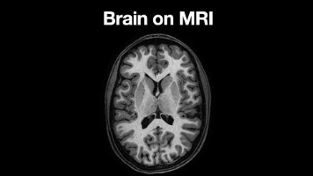

Brain stroke prediction-using dataset: ISLES-2022

Important dataset:

EEG SIGNAL CLASSIFICATION  
dataset:https://openneuro.org/datasets/ds005565/versions/1.0.3

BCI latest dataet

<https://dataverse.harvard.edu/dataset.xhtml?persistentId=doi:10.7910/DVN/ELKTTR>

<https://osf.io/search?activeFilters=%5B%7B%22propertyVisibleLabel%22%3A%22Date%20created%22%2C%22propertyPathKey%22%3A%22dateCreated%22%2C%22label%22%3A%222024%22%2C%22value%22%3A%222024%22%7D%2C%7B%22propertyVisibleLabel%22%3A%22Subject%22%2C%22propertyPathKey%22%3A%22subject%22%2C%22label%22%3A%22Neuroscience%20and%20Neurobiology%22%2C%22value%22%3A%22https%3A%2F%2Fapi.osf.io%2Fv2%2Fsubjects%2F584240da54be81056cecabfd%22%7D%2C%7B%22propertyVisibleLabel%22%3A%22Resource%20type%22%2C%22propertyPathKey%22%3A%22resourceNature%22%2C%22label%22%3A%22Dataset%22%2C%22value%22%3A%22https%3A%2F%2Fschema.datacite.org%2Fmeta%2Fkernel-4%2F%23Dataset%22%7D%5D&q=eeg%20data&sort=-dateCreated>

<https://www.kaggle.com/datasets/kapilesha/brainmetshare>

Eeg classification dataset

<https://data.mendeley.com/datasets/rcdsfxdztb/1>

EEG,EMG Dataset best Link

<https://ai.scidb.cn/en>

[EMG Python Tutorial Part 1](https://www.youtube.com/watch?v=F6P9tWrgSZo)

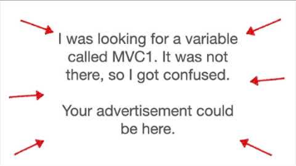

<https://physionet.org/content/auditory-eeg/1.0.0/#files-panel>

<https://openneuro.org/datasets/ds004504/versions/1.0.8>

<https://www.mdpi.com/2306-5729/8/6/95>

<https://medium.com/the-ultimate-bedroom-bci-guide>